**WILLIAM LILLEY**

**INFANT AND NURSERY SCHOOL**



**Physical Intervention and Restrictive Practice Policy (Use of Reasonable Force)**

|  |  |
| --- | --- |
| **Governors’ Committee Responsible:** | **Outcomes and Data** |
| **Policy Originator:** | **Nottinghamshire LA** |
| **Date policy written:** | **November 2024** |
| **Approved by Governors** | **December 2024** |
| **Next review date** | **Autumn 2025** |

1. **Introduction**

The use of Restrictive Practices Policy has been developed to ensure that staff, pupils, parents/carers, and governors have an understanding of school guidelines for supporting pupils who have reached crisis point and are displaying behaviours that may put themselves or others in physical danger. Following these guidelines will ensure pupils are able to learn, and staff are able to teach, in a safe and secure environment.

This Policy will be applied consistently to pupils regardless of their age, SEND, sex, gender reassignment, sexual orientation, race, faith background or personal circumstances. Respect for these protected characteristics will be considered as an important part of the whole school Inclusive practice and ethos.

Physical Intervention or Restrictive Practice is traumatising for all people involved and their use often damages relationships.

***‘Physical restraint can be humiliating, terrifying and even life-threatening. It should only be used as the last resort, when there is no other way of de-escalating a situation where someone may harm themselves or others’ (Campbell, 2018).***

As a school, we are committed to reducing the need to use restrictive practices. We recognise that restrictive physical interventions are only entered into as a last resort when dealing with potentially dangerous situations, where there is a risk of harm to children or adults. Restrictive physical interventions must only be used in a person’s best interest and comply with William Lilley Infant and Nursery Schools duty of care to students, staff, and visitors.

**This policy has been prepared using the following guidance:**

* [Reducing the need for restraint and restrictive intervention (publishing.service.gov.uk)](https://assets.publishing.service.gov.uk/government/uploads/system/uploads/attachment_data/file/812435/reducing-the-need-for-restraint-and-restrictive-intervention.pdf)
* [Keeping children safe in education 2024: part one (publishing.service.gov.uk)](https://assets.publishing.service.gov.uk/media/66ce094e8e33f28aae7e1f6d/Keeping_children_safe_in_education_2024_part_one.pdf)
* [Reasonable force, restraint & restrictive practices in alternative provision and special schools (publishing.service.gov.uk)](https://assets.publishing.service.gov.uk/media/65eee4ba3649a26deded6320/Reasonable_force__restraint_and_restrictive_practices_in_alternative_provision_and_special_schools.pdf)
* [Reducing restrictive practices framework [HTML] | GOV.WALES](https://www.gov.wales/reducing-restrictive-practices-framework-html)
* [TSS_diagram_REVISED (restraintreductionnetwork.org)](https://restraintreductionnetwork.org/wp-content/uploads/2023/09/Six-Core-Strategies-and-Human-Rights.pdf)
* Education and Inspections Act 2006 - Section 93
* BILD code of Practice for minimizing the use of restrictive physical interventions; 4th Edition (BILD 2014)

This policy is available:

* Online at [www.williamlilley.notts.sch.uk](http://www.williamlilley.notts.sch.uk)
* From the school office

1. **The Legal Framework**

**Restrictive Practices**

Restrictive practices are all practices which limit the freedom and independence of children to learn. They include the mildest of practices, for example, requiring children to follow a prescribed timetable and curriculum, through to the most restrictive of practices, for example, the use of physical intervention and restraint.

The key principle which underpins our decisions about the use of restrictive practices is that their use should be as minimal as possible whilst ensuring the safety of the child, other children, and the adults working with them. There will be occasions when to ensure safety and to minimise the risk of harm, adults may need to physically intervene, restrain a child, or impose a restriction on their liberty.

**Restraint and deprivation of liberty**

*Restraint in relation to a child is only permitted for the purpose of preventing— (a) injury to any person (including the child); (b) serious damage to the property of any person (including the child).* (2) *Restraint in relation to a child must be necessary and proportionate.*

**Seclusion**

*“Seclusion involves separating an adult or child against their will, restricting freedom of movement and forcing them to spend time alone.”* Joint guidance from the Department of Health and DFES (July 2002)

**Seclusion may only be used when:**

A pupil is posing a risk of injury to themselves or others due to behaviours such as biting, head butting, kicking and they need time in a ***safe environment*** with a trusted adult to help them calm. No child should be left in isolation within a contained environment with locked doors or barriers in place which places the child’s well-being and/or safeguarding at risk.

**Staff Authorised to Use Reasonable Force**

Under Section 93 of the Education and Inspection Act (2006) and subsequent guidance published by the DfE in January 2016 entitled ‘Behaviour and Discipline in Schools – Guidance for Headteachers and Staff’ the Headteacher at our school is empowered to authorise those members of his/her staff to use reasonable force.

Here at William Lilley Infant and Nursery School the Headteacher has empowered the following members of staff to use reasonable force:

* Teachers and any member of staff who have direct responsibility and a duty of care of pupils in school
* Other members of staff such as site management and administrative teams also have the power to use reasonable force if a circumstance should arise in which immediate action should be taken to reduce the risk of harm

**The** **Designated Safeguarding Lead** (DSL) and Deputies in our school is/are: Mrs Sally Beardsley, Miss Trudy McMahon, Mrs Helen Jeffery and Mrs Victoria Yard. Safeguarding is the responsibility of all, however all staff, parents/carers and pupils need to be aware of who to report to and how to report any safeguarding concerns.

**The nominated Governor** with responsibility for Safeguarding is: Mrs Anthea Tainton

**The nominated Governor** with responsibility for Mental Health and Wellbeing is: Mr Aaron Eames

**Deciding Whether to Use Reasonable Force**

*Under Section 93 of the Education and Inspection Act (2006), members of staff are empowered to use reasonable force to prevent a pupil from or stop them continuing:*

* *committing any offence*
* *causing personal injury to, or damage to the property of, any person (including the pupil himself); or*
* *prejudicing the maintenance of good order and discipline at the school or among any pupils receiving education at the school, whether during a teaching session or otherwise*

All members of staff will make decisions about when, how, and why to use reasonable force. To help staff in making decisions about using reasonable force the following considerations may be useful:

* whether the consequences of not intervening would have seriously endangered the wellbeing of a person
* whether the consequences of not intervening would have caused serious and significant damage to property
* whether the chance of achieving the desired outcome in a non-physical way was low
* making an assessment on the age, size, gender, developmental maturity of the persons involved

Staff will be kept informed and have a duty to inform others about the Behaviour plans around specific pupils who can present risks to themselves and others. This may include information about SEND, personal circumstance, and any experiences of trauma.

1. **School Expectations**

All staff should adopt a positive approach to improving behaviour to reward effort and build self-esteem. We work in partnerships with those who know the child best to:

* **Establish the functions of behaviours being displayed**
* **Understand the factors that may influence a child’s behaviour**
* **Identify early warning signs that indicate foreseeable behaviours are developing**

This approach will help to ensure that the use of early and proactive strategies is common practice. It aims to reduce the incidence of extreme behaviours and supports the reduction of restrictive practices in school.

Our whole school approach is underpinned by trauma informed and attachment aware practice. Our relational policy identifies how we support children to manage their own regulation and provide strategies such as emotion coaching and Elsa to help develop this over time.

Staff should, where possible, avoid any type of intervention that is likely to injure a pupil, unless in the most extreme of circumstance where there was no viable alternative. Staff should try to avoid using force unless or until another member of staff is present to support, observe or call for assistance.

**Reducing the need to Intervene Physically**

Although preventative measures may not always work, there are several steps which can be taken to help reduce the likelihood of situations arising where the power to use force may need to be exercised:

* Creating a calm, orderly and supportive school climate that minimises the risk and threat of violence of any kind
* Developing effective relationships between pupils and staff
* Adopting a whole-school approach to Inclusive practice
* Taking a structured approach to staff development that supports staff to use positive behaviour management strategies; managing conflict and to support one another during and after an incident
* Effectively managing individual incidents using a low-arousal response. Communicate calmy with the pupil; use non-threatening verbal and body language and ensure the pupil can see a way out of a situation in a supported manner
* Teaching pupils strategies to use in a crisis (such as sensory integration, clear communication and non-verbal signals to indicate the need for support)
* Whenever practical, warning a pupil that force may have to be used before using it
* Ensuring that staff and volunteers are aware of the pupils’ Behaviour Plans and understand situations which may provoke difficult behaviour, triggers, preventative strategies, and de-escalation techniques

**Key Principles surrounding the use of a restrictive physical intervention.**

1. Consider if you really need to use a restrictive physical intervention. If so then use the least restrictive first and return to the least restrictive as soon as possible.
2. Staff should not enter into a restrictive physical intervention if on their own, help must always be sought.
3. Physical Interventions should be employed using the minimum reasonable force for the shortest duration of time as possible and should not cause pain.
4. Staff should be assessing signs of injury or psychological distress during and after the intervention.
5. Staff should always avoid touching or restraining a pupil in a way that could be interpreted as sexually inappropriate conduct.

**Use of restrictive physical interventions in unforeseen and emergency situations.**

On occasion, staff may find themselves in unforeseen or emergency situations when they have no option but to use reasonable force to manage a child in crisis. E.g. where there is a high and immediate risk of death or serious injury to the child or others. Any member of staff would be justified in taking any necessary action to safeguard the child from harm.

**Staff should:**

* Before using force- staff attempt to use diversion or diffusion to manage the situation.
* Staff should always report and record any use of physical intervention that occurs in unforeseen and emergency situations using school procedures.
* Parents/carers will always be informed immediately if physical force is used on their child.
* In line with Health and Safety Guidance on approved methods of physical intervention at **NO** time is a young person to be placed in a **Prone Restraint** (face down) or **basket holds or wraps** (the child’s arms held around their own abdomen as these methods of restraint are barred under Health and Safety Guidance.

**Behaviour Plans (also known as personal safety plan)**

All children who have the potential to display behaviours of concern either linked to SEND or Trauma will have a **Behaviour Plan** document which details appropriate adult responses when supporting the child through co-regulation. (Appendix A)

**Staff training**

Staff will be trained in accordance with guidance from the Restraint Reduction Network and BILD (code of practice)

All staff in school will access training on behaviour management and support through regular Personal Development Meetings and Individual Appraisal.

We will seek advice from NCC’s Inclusive Behaviour Co-ordinator about the level of training considered appropriate to our setting. This will be assessed following the completion of an annual audit.

In addition, all staff will have access to ongoing bespoke advice and guidance tailored to the needs of our setting through the use of anonymised consultations about the needs of individual children as and when required. Staff who receive training through NCC’s Inclusive Behaviour Co-ordinator will be certified by the Local Authority for a defined period as stated on their certificate. Staff will be expected to attend a refresher course to update their skills and renew their certification every 18-24 months.

**Recording and Reporting Incidents**

The governing body will ensure that a procedure is in place, and is followed by staff, for recording and reporting significant incidents where a member of staff has used reasonable force on a pupil, in line with the most recent safeguarding requirements issued to Governors and the latest advice given to OFSTED inspectors.

Any use of restrictive practice is seen as significant and **must** be reported clearly and concisely as soon as practicable after the incident.

School staff should consider and include in the report:

* the pupil’s behaviour and the level of risk presented at the time
* the degree of force used and whether it was proportionate in relation to the behaviour
* the effect on the pupil or member of staff

Staff should also bear in mind the age of the child; any special education need or disability or other social factors which might be relevant. Sometimes an incident might not be considered significant in itself, but forms part of a pattern of repeated behaviour. In this case, although there is no legal requirement to record such incidents, schools are advised to let parents/carers know about them.

Records are important in providing evidence of defensible decision-making in case of a subsequent complaint or investigation. Staff may find it helpful to seek the advice of a senior colleague or a representative of their trade union when compiling a report.

After incidents in which a restrictive physical intervention is used, staff should report and record the matter in accordance with school procedure, including informing parents/legal guardian. All incidents requiring the use of restrictive physical intervention should be thoroughly and systematically documented within school records using CPOMS.

The incident must be directly reported to the Headteacher, and staff involved will be debriefed to review and analyse the incident. A review and analysis of the incident will take place as soon as possible thereafter, and safety passports will be updated with the aim of ensuring any lessons are learned and any identified changes to the environment or support plans are acted upon/implemented.

1. **Post-incident Support**

Incidents that require use of restrictive physical interventions can be upsetting to all concerned and can result in injuries to the child or staff. After an incident has subsided, it is important to ensure that staff and children are given emotional and psychological support and basic first aid treatment for any injuries. Immediate action should, of course, be taken to ensure that medical help is accessed for any injuries that require more than basic first aid. All injuries should be reported and recorded in accordance with school procedures.

**Repair and Restore Relationships through Restorative Conversations**

Restrictive practice damages relationships. It is vital that the child is given the opportunity to reflect on the incident with the support of the adults involved to ensure the child’s voice is captured and any restoration can be implemented as a result to repair any harm and facilitate open, direct communication.

Key questions to support a restorative conversation with the child:

* What happened?
* How did you feel………….?
* Who was affected by this?
* What needs to happen now?
* What could we have done differently?

1. **Complaints and allegations**

William Lilley Infant and Nursery school will also make clear to pupils that they have a right, and are able, to question/complain about the use of reasonable force. We will ensure that mechanisms are in place for pupils, parents, carers, and staff to voice their opinions, comments, or concerns.

Complaints and allegations will be taken seriously, and should follow the guidance identified within the complaints procedure.

**The role of the LADO:**

Working together to Safeguard Children (2023) requires each Local Authority to have a LADO. In Nottinghamshire the role of the LADO is undertaken by the Managing Allegations Service.

The purpose of the LADO role is to address allegations/concerns made against adults working or volunteering with children in Nottinghamshire.

Working together to Safeguard Children (2024) and Keeping Children Safe in Education (2024) outline the criteria to be applied to allegations and concerns about an individual when it is indicated the individual may have:

* Behaved in a way that has harmed a child or may have harmed a child;
* Possibly committed a criminal offence against or related to a child;
* Behaved towards a child or children in a way that indicates they may pose a risk of harm to children;
* Behaved or may behave in a way that indicates they may not be suitable to work with children.

Concerns may relate to either a person’s work/voluntary role or their behaviour outside the work setting.

**LADO role in Restraints of under 18s**

**The LADO should be notified when:**

* A child is injured or may have been injured as a result of appropriate/permitted restraint practice or actual/perceived use of excessive force,
* A child and/or parent/carer makes an allegation and/or complaint against a professional following a restraint of a child,
* A professional, other adult or child reports an observed or perceived inappropriate restraint of or practice with a child by another professional.

**The responsibility of the employer/person receiving the complaint is to:**

* Ensure the child is safe and refer to MASH/Police as appropriate
* Consider the actions required to safeguard this child and other children in the setting
  + Refer to LADO using the LADO Online Contact Form (link below) providing clear details of the incident, the adult of concern (including personal details to safeguard the adult’s own children- consider any additional voluntary roles the adult holds); details of the child and your own details.

**Link to LADO online Contact Form** - [Submit a LADO Contact Form](https://forms.nottinghamshire.gov.uk/en/AchieveForms/?form_uri=sandbox-publish://AF-Process-a9938db1-3381-4fd8-bca4-c28f900976c6/AF-Stage-353ce56e-fade-4573-9663-918bd0a48fbc/definition.json&redirectlink=%2Fen&cancelRedirectLink=%2Fen&consentMessage=yes)

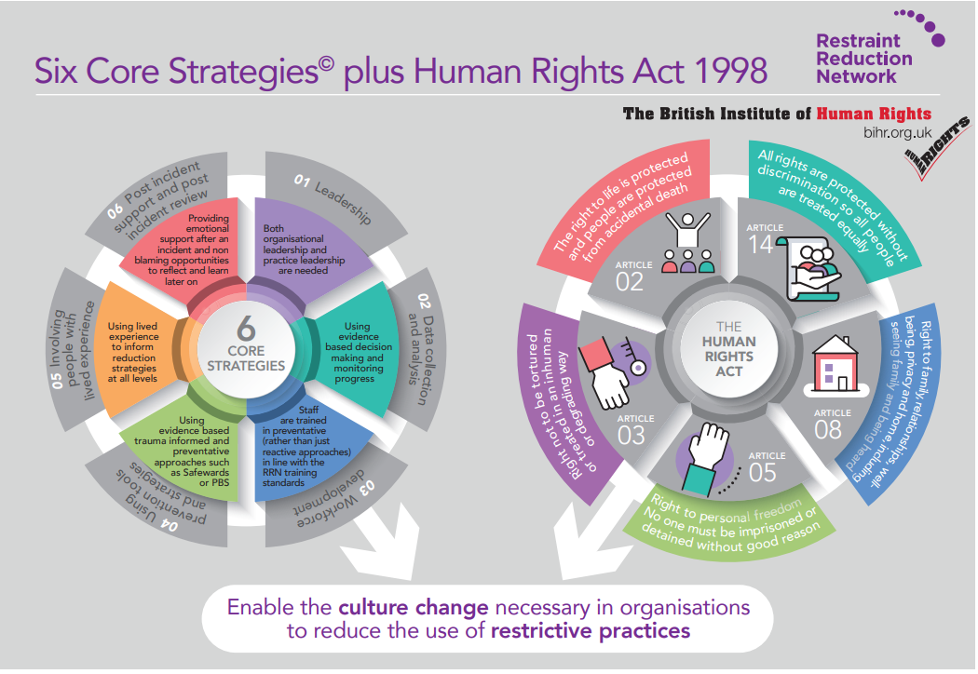

**APPENDIX A**

**INDIVIDUAL BEHAVIOUR PLAN (PERSONAL SAFETY PLAN)**

|  |
| --- |
| **NAME** |

|  |
| --- |
| **SCHOOL POLICY**  Is based on the principle that the physically handling of young people is only used in the most extreme situations and where one for younger children or two members of staff are present. Staff have a duty of care to ensure the safety of **** ****, other young people, themselves and property. Physical intervention will only be used as a last resort when all other de-escalation strategies outlined below have been exhausted and there is imminent risk of harm to self, others or property. Staff working with **** will receive approved accredited training which is regularly monitored and reviewed in line with current Local Authority guidelines. |

|  |
| --- |
| **BEHAVIOUR REQUIRING INTERVENTION**   * Throwing objects which may be put ****, or others at risk * Any behaviour which affects the health and safety of ****, other pupils or staff. |

|  |
| --- |
| **STAFF PROCEDURES**  **THE FOLLOWING PROCEDURES ARE IMPLEMENTED WHEN MANAGING ****S BEHAVIOUR**  **Positive strategies to support **** and manage his behaviour.**  **Through our duty of care we set out the following procedures in the classroom and when managing ****;**  **If the health and safety of other children are at risk;**  **Refusal to follow the above instruction/request** |

|  |
| --- |
| **MEDICAL INFORMATION** |

|  |
| --- |
| **TRIGGERS THAT PRODUCE CHALLENGING BEHAVIOUR** |

|  |
| --- |
| **METHODS TO CONSIDER TO HELP END THE PHSICAL INTERVENTION** |

|  |
| --- |
| **OTHER INFORMATION** |

**Staff Response Grid**

|  |  |  |  |
| --- | --- | --- | --- |
|  |  | Behaviour Observed  ‘What do we see?’ | Staff Response  ‘What do we do?’ |
|  | Baseline behaviour – When **** is calm, settled and focused. | * Calm and focused body language * Talking to others * Eye contact * Smiling, will tolerate positive touch * Plays happily and talks to other children * Focused on work/play | * Look for any signs of anxiety – be aware that this may lead to an escalation once **** has processed the anxiety. |
| R | Trigger phase – When we recognise that **** is anxious and has moved away from his baseline. | * Will not tolerate positive touch * Change in facial expression and body language towards other children and adults * Growls | * Distraction * Reducing demands * Favourite objects * Use very few words – indirect demands eg A or B? * Ask ‘What can I do to help you’ in a calm manner |
| E  S  P | Escalation phase – ****’s behaviour continues to become difficult and increasingly reckless. | * Grabbing, snatching etc * Tips/swipes resources * Kicks out * Throwing objects * Runs * Screws things up | * Move to sensory room or nest * Cuddling to calm * Blanket * Cushions to hit * Soft balls to throw in sensory room * Weighted blanket * Apply gentle pressure to help regulate/calm |
| O | Crisis phase – ****’s behaviour puts himself, others or property at serious risk. | * Physically harming others (pupils and staff) * Throwing objects (chairs, desks, books) that may cause physical harm or damage (pupils and staff). * Any behaviour which affects the health and safety of ****, other pupils or staff. | * Staff may have to intervene to physically manage ****’s behaviours for as short a time as is necessary but for as long as is needed. * Take **** to a different, calmer environment thus allowing him to calm down or sleep |
| N  S | De-escalation phase – The crisis has passed but **** is still highly emotional aroused. | * Upset * Agitated * Fall asleep | * Staff will offer **** a range of activities designed to engage him and return his mood to baseline – this is **NOT** about rewarding negative behaviours but strategies employed to ‘de-escalate’ the level of arousal. This will take place in a calm environment eg, sensory room, nest * Talk with **** about unrelated topics and allow him time to engage in enjoyable activities. |
| E | Post-Crisis phase – When all involved are back at baseline. |  | * What learning can the staff team take from this incident? Are there any changes we can make that may help us avoid another incident in the future? * Contact family to inform them of the incident. |

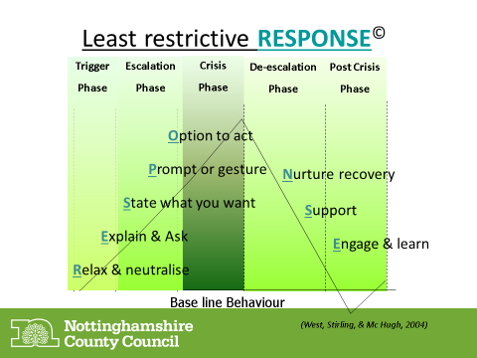

|  |
| --- |
| DATE: |
| SIGNED (parents) |
| SIGNED (Headteacher)  SIGNED (SENCO) |
| SIGNED (Staff working with ****) |